Table of Contents

CASE 1 2

CASE 2 5

CASE 3 7

CASE 4 8

CASE 5 10

# CASE 1

A new table 'staff_ details' is needed as staffs can be added easily as well as when a staff go deleted constraint checks can be done before removing the staff

The staff_ details table can be extended, if more staff information like id, address or payroll information has to be stored.

The primary benefit of constructing a mapping or reference table is that it allows us to extend, modify, and edit certain elements of a table.

Otherwise, gathering information from the staff table and making necessary changes will be very challenging.

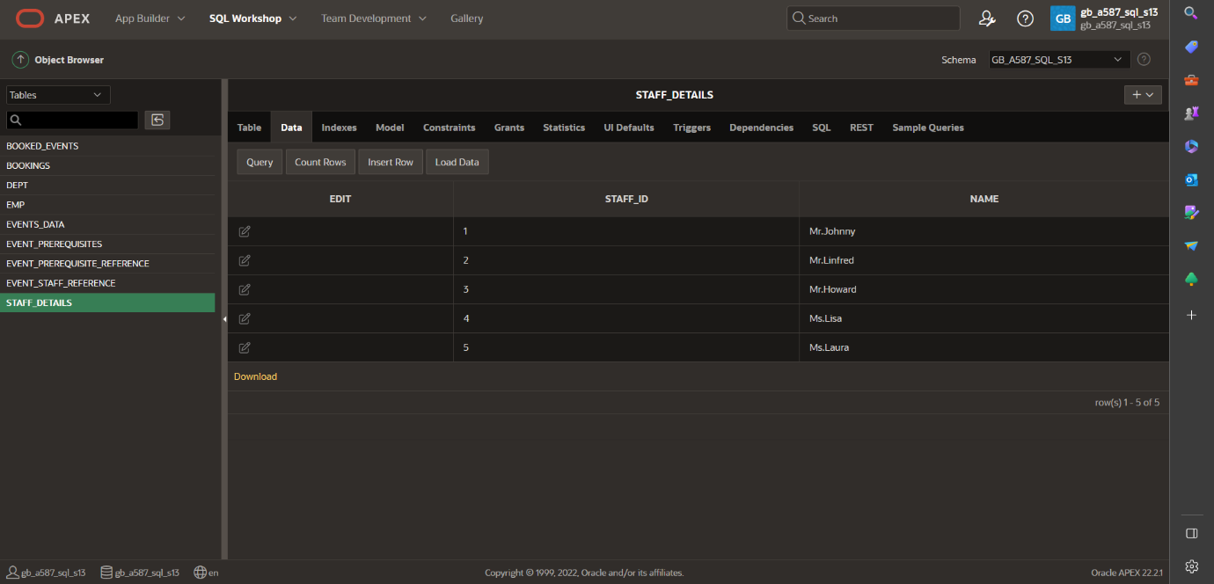

Table 1.1 STAFF_DETAILS

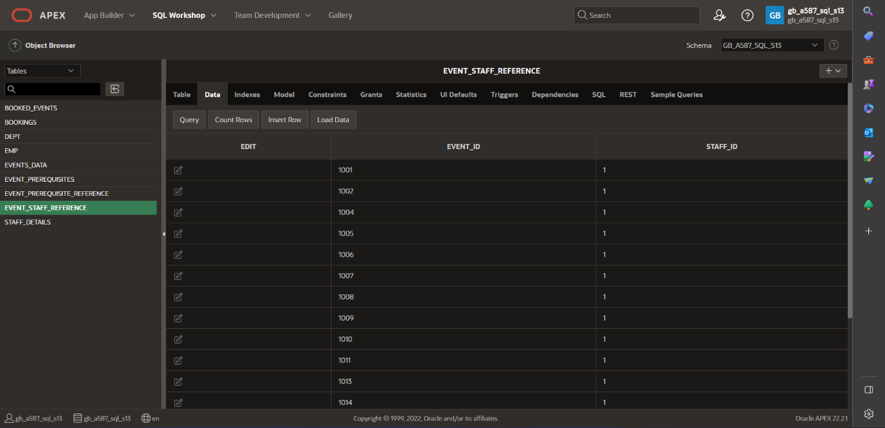

Table 1.2 EVENT_STAFF_REFERENCE

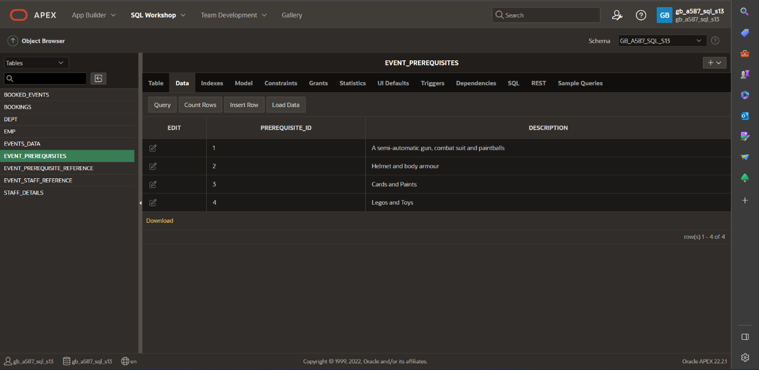

Table 1.3 EVENT_PREREQUISITIES

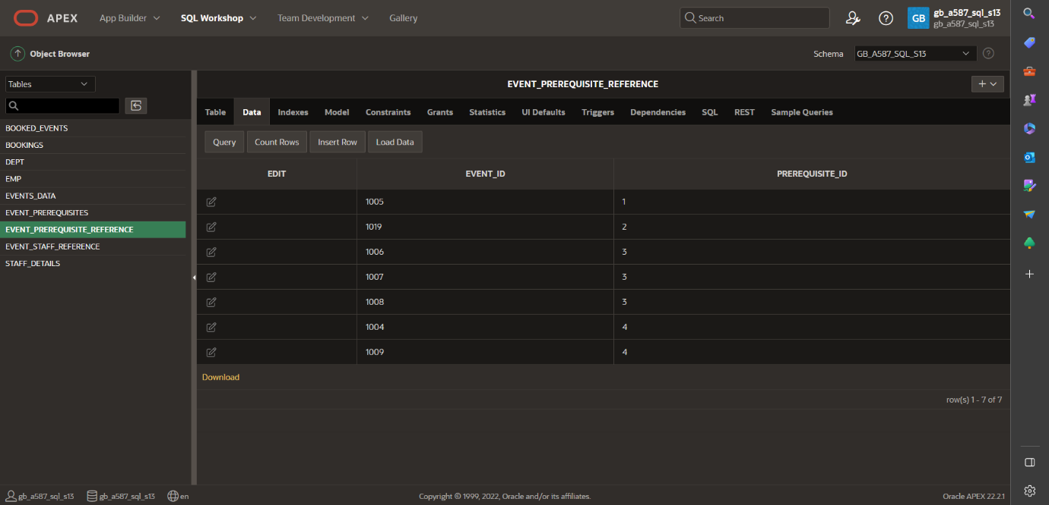

Table 1.4 EVENT_PREREQUISITE_REFERANCE

# CASE 2

select * from events_ data where event_ name='Supercar driving';

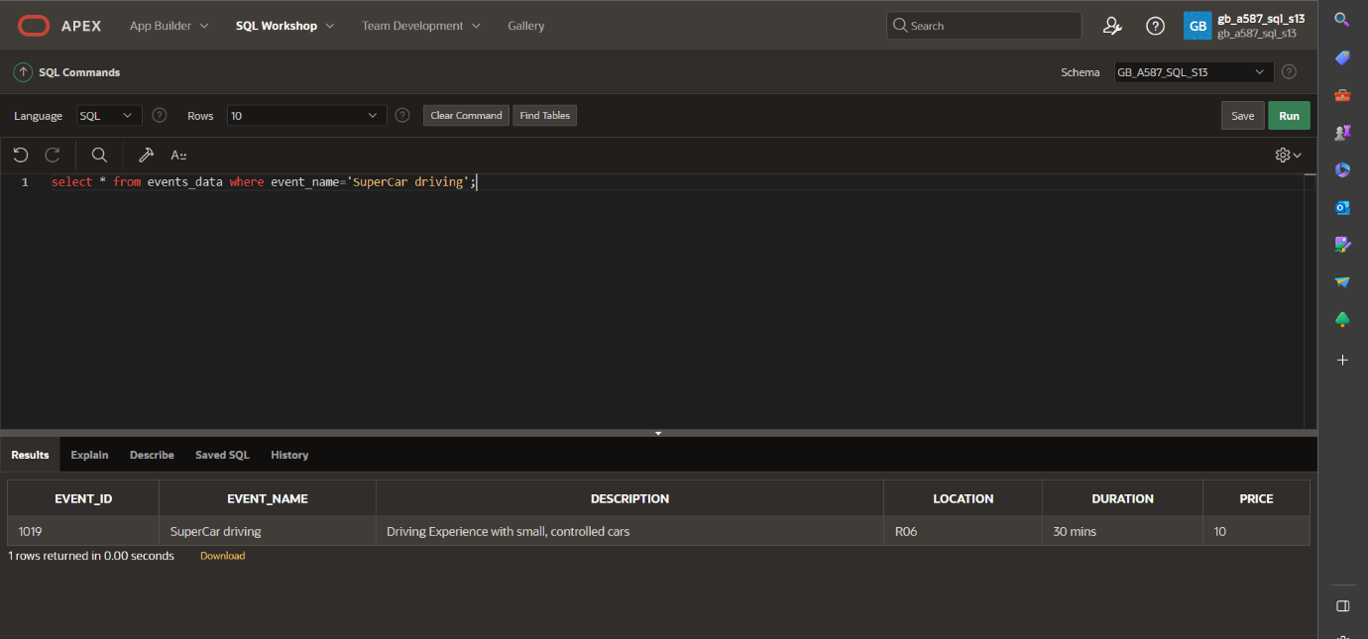

Figure 2.1 event details based on event name

B.

select * from events_ data where price <= 30;

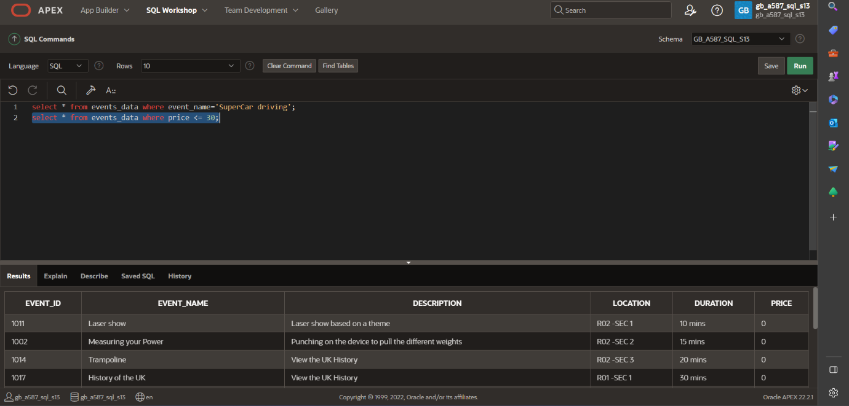

Figure 2.2 event details based on price

C.

select * from bookings where customer_ details like '%Mr. Kemiln %';

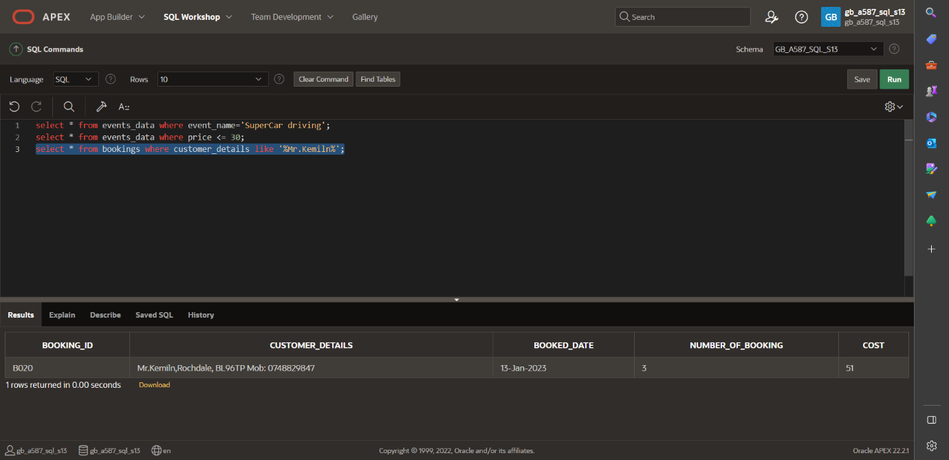

Figure 2.3 order details for a customer name.

D.

select * from bookings where booked_date =TO_DATE('12/01/2023', 'DD/MM/%YYYY');

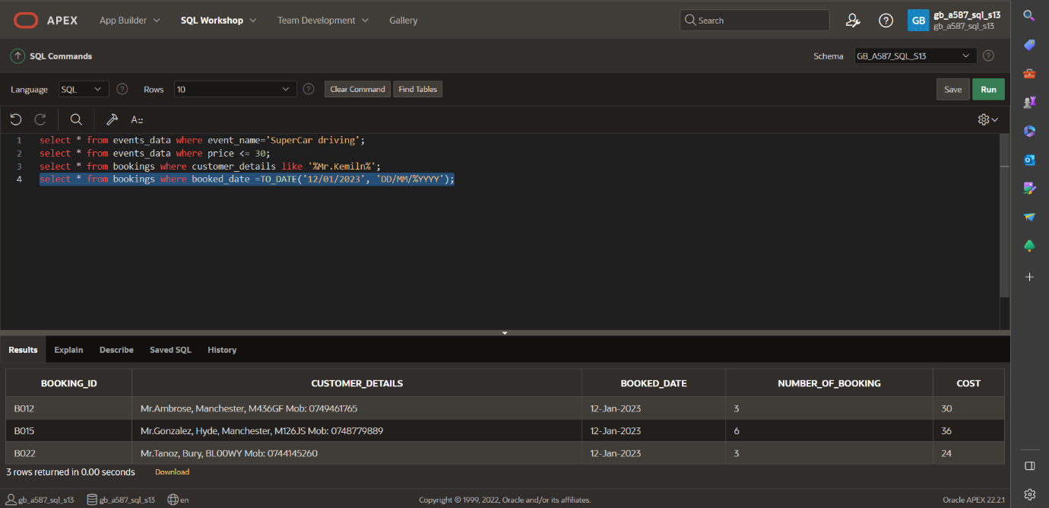

Figure2.4 order details for a particular date.

# CASE 3

Event update

update events_ data set price=0.00 where event_ name='Rocket Launchers';

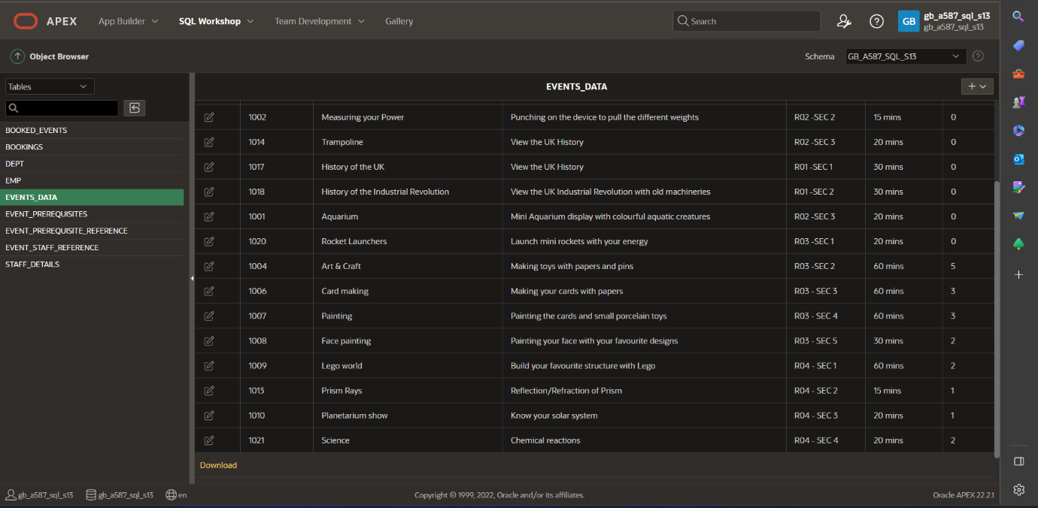

# CASE 4

insert into bookings (booking_ id, customer_ details, booked_ date, number_ of_ booking, cost) values ('B026', 'rose, dahlwitzer street, berlin', TO_DATE('30/04/2023', 'DD/MM/YYYY'), 6, 120.00);

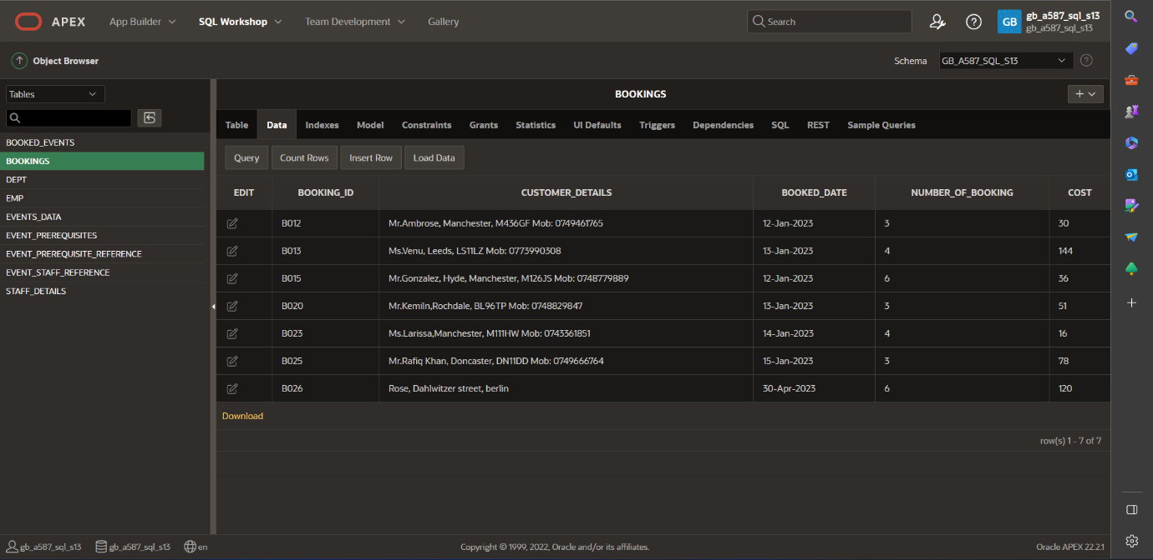

FIGURE 3.1

delete from booked_events where booking_id= 'B022';

delete from bookings where booking_id = 'B022';

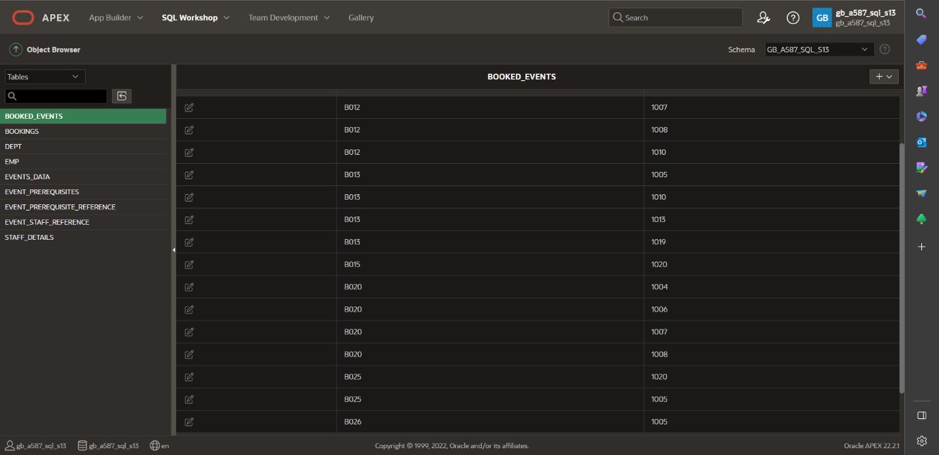

FIGURE 3.2

# CASE 5

STATISTICS

select sum(number_ of_ booking) as Total_ Number_ of_ Booklings, sum(cost) as Total_ cost from bookings;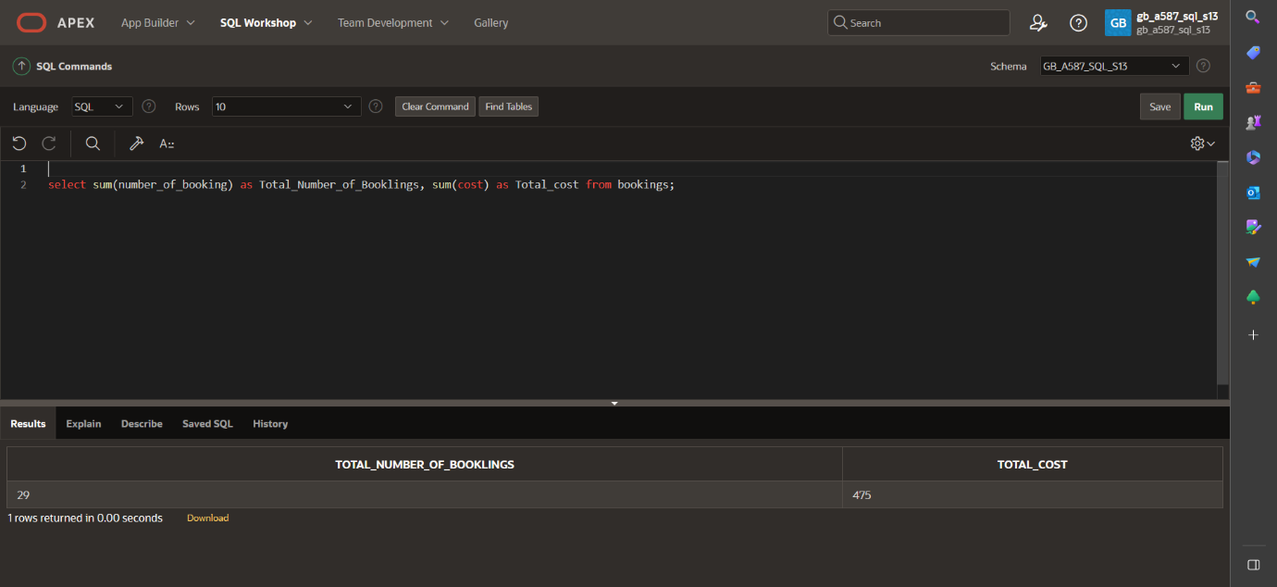

Figure 4.1